**Realising the Right to a Basic Education: Dialogue and Launch of Report**

**04 November 2015, Women’s Gaol, Constitution Hill**

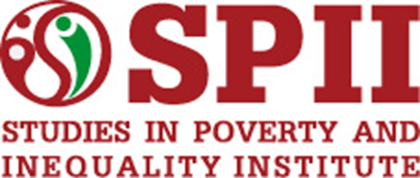

**PROGRAMME**

|  |  |  |
| --- | --- | --- |
| **Time** | **Session** | **Facilitator/speaker** |
| 09:00 – 09:20 | Registration | SPII |
| 09:20 – 09:30 | Welcoming remarks | Foundation for Human Rights |
| 09:30 – 09:35 | Introduction and Programme | Chair (Isobel Frye, SPII) |
| 09:35 – 10:00 | Key Note Address | Salim Vally, Director: Centre for Education Rights and Transformation, University of Johannesburg |
| 10:00 – 10:40 | Launch of report:  ‘Realising the Right to a Basic Education in South Africa’ | Shaun Franklin and Daniel McLaren, SPII |
| 10:40 – 10:50 | Tea break | |
| 10:50 – 11:10 | Reply by National Department of Basic Education | Department of Basic Education (TBC) |
| 11:10 – 11:30 | Reply by Gauteng Provincial Education Department | Albert Channee, Deputy-Director General for Education Policy and Planning: Gauteng Department of Education |
| 11:30 – 11:50 | Reply by South African Democratic Teachers Union (SADTU) | SADTU (TBC) |
| 11:50 – 12:50 | Questions and Discussion | Chair |
| 12:50 – 13:00 | Thanks and closing remarks | Chair |
| 13:00 – 14:00 | Lunch | |

