**Realising the Right to Basic Education in South Africa: Dialogue and Launch of Report : Women’s Goal Constitution Hill Johannesburg**

**4th November 2015**

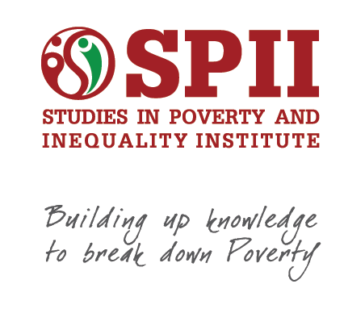

**PARTICIPANT REGISTRATION FORM**

Please complete the Registration Form below and email it back to [Matshidiso@spii.org.za](mailto:Matshidiso@spii.org.za) cc [advocacy@spii.org.za](mailto:advocacy@spii.org.za) by **Tuesday 23rd October 2015** or contact Matshidiso Motsoeneng on 011 833 0161

|  |  |
| --- | --- |
| **Title *(Prof/Dr/Mr/Mrs/Ms)*** |  |
| **First Name** |  |
| **Surname** |  |
| **Organisation** |  |
| **Location** |  |
| **Telephone** |  |
| **Email** |  |
| **Need parking? Registration number and car model** |  |
| **Dietary Requirements** |  |
| **Do you need assistance with transport costs?**  A very limited amount of funds are available to assist participants travelling from **outside Gauteng** with **flight and airport transfer costs**. If your organisation is unable to assist you with these costs please provide details here. We will contact you by 23rd October 2015 to notify you if we are able to assist with these costs. |  |



